PROJECT 1: RULE-BASED AI CHATBOT
Submitted By
Vaishnavi Nalla
Internship
DecodeLabs AI Internship

1. Introduction
Artificial Intelligence is transforming the way humans interact with computers. One of the simplest applications of AI is a chatbot, which can communicate with users and provide responses based on predefined rules.
In this project, a Rule-Based AI Chatbot was developed using Python. The chatbot responds to user inputs using conditional statements and predefined responses. This project helped in understanding the basic concepts of conversational AI, user input handling, loops, and decision-making logic.

2. Objective
The objective of this project is to create a simple chatbot that can interact with users and provide appropriate responses based on predefined rules.
The project focuses on:
- Understanding chatbot fundamentals
- Taking user input
- Processing user queries
- Responding with predefined answers
- Implementing decision-making logic using Python

3. Technologies Used
Programming Language
- Python
Development Environment
- Google Colab
Version Control
- GitHub

4. Project Overview
The chatbot works by accepting text input from the user and comparing it with predefined conditions.
Based on the user's input, the chatbot generates a suitable response.
The chatbot can answer basic questions such as greetings, introductions, and simple conversational queries.
If the input does not match any predefined condition, the chatbot displays a default response.

5. Working of the Chatbot
The chatbot follows a simple workflow:
Step 1: Start the Program
The chatbot starts running and waits for user input.
Step 2: Accept User Input
The user enters a message.
Step 3: Process Input
The chatbot checks the input against predefined conditions.
Step 4: Generate Response
If a matching condition is found, the chatbot provides the corresponding response.
Step 5: Continue Conversation
The chatbot continues interacting until the user exits the program.

6. Key Concepts Used
The following Python concepts were used:
- Variables
- Conditional Statements (if, elif, else)
- Loops
- User Input Handling
- String Comparison
- Basic Conversational Logic
These concepts helped build a simple interactive chatbot.

7. Project Workflow
- Import Required Components
- Create Chatbot Responses
- Accept User Input
- Compare User Input with Conditions
- Display Appropriate Responses
- Continue Conversation Using Loops
- Exit When User Chooses to Stop

- Output Screenshots
Screenshot 1: Chatbot Program Execution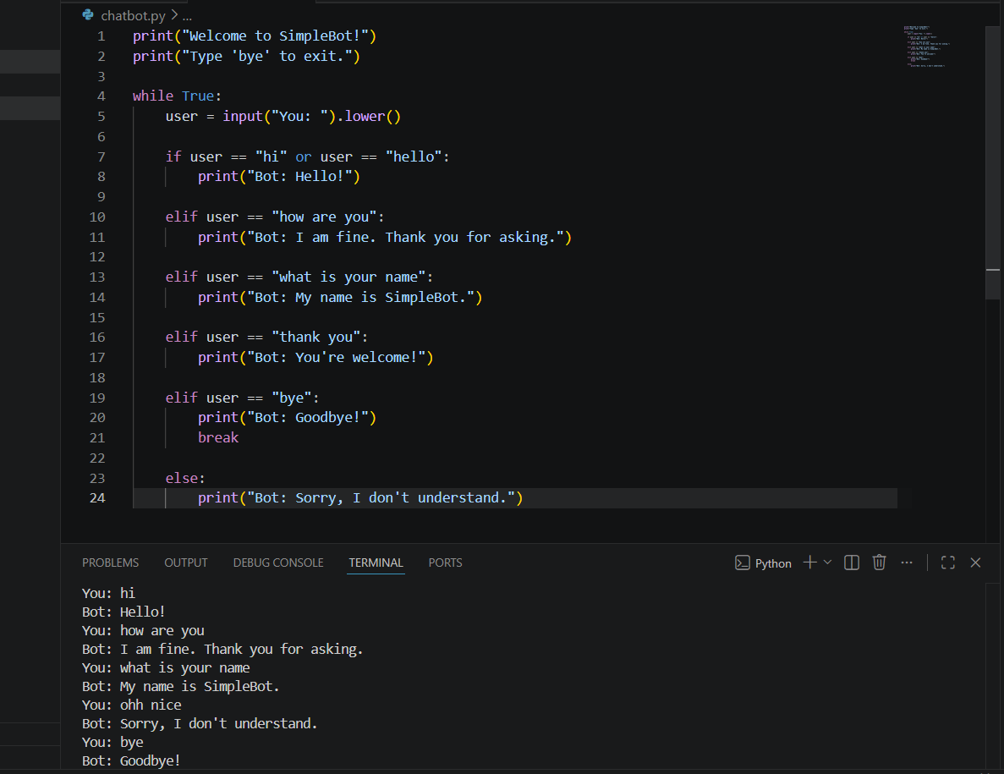

Screenshot 2: User Interaction



9. Results
The chatbot successfully responded to predefined user inputs and maintained basic conversations.
The chatbot correctly identified matching inputs and generated appropriate responses according to the programmed rules.

10. Applications of Rule-Based Chatbots
Rule-based chatbots are commonly used in:
- Customer Support Systems
- FAQ Assistants
- Educational Platforms
- Banking Services
- Healthcare Information Systems
- Website Assistance Bots
These chatbots help automate simple interactions and improve user experience.

11. Challenges Faced
During the project, understanding how to handle multiple user inputs and manage conversational flow required careful planning.
Additional effort was spent learning:
- Conditional logic
- User input processing
- Conversation design
- Loop implementation
These challenges improved programming and problem-solving skills.

12. Future Improvements
Possible future enhancements include:
- Natural Language Processing (NLP)
- Voice-Based Interaction
- Machine Learning Integration
- Improved Conversation Handling
- Context-Aware Responses
- Multi-Language Support
These improvements can make the chatbot more intelligent and user-friendly.

13. Conclusion
This project successfully demonstrated the development of a Rule-Based AI Chatbot using Python. The chatbot was able to accept user input, process predefined conditions, and provide appropriate responses.
The project strengthened understanding of Python programming, conditional statements, loops, user input handling, and the fundamentals of conversational AI. It provided a strong foundation for exploring more advanced chatbot and Artificial Intelligence applications in the future.

14. GitHub Repository
GitHub Repository Link:
https://github.com/NallaVaishnavi/DecodeLabs-Internship-Project1

